PHYSICS 1, CHAPTER 5
ADDITIONAL PROBLEMS

1. A rope of negligible mass is stretched horizontally between two supports that are 3.44 m apart. When an
object of weight 3160 N is hung at the center of the rope, the rope is observed to sag by 35.0 cm. What is the tension in the rope?
ANSWER: 7.92 kN
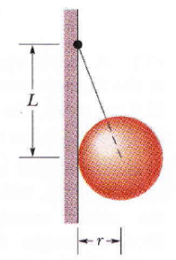
2. In Fig. 1, a uniform sphere of mass m = 0.85 kg and radius r = 4.2 cm is held in place by a massless rope attached to a frictionless wall a distance L = 8.0 cm above the center of the sphere. Find
Fig. 1
(a) the tension in the rope and
(b) the force on the sphere from the wall.
ANSWER: (a) 9.4 N; (b) 4.4 N
3. A meter stick balances horizontally on a knife-edge at the 50.0 cm mark. With two 5.00 g coins stacked over the 12.0 cm mark, the stick is found to balance at the 45.5 cm
mark. What is the mass of the meter stick?
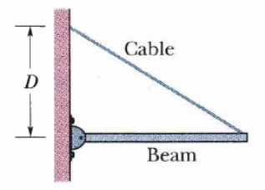
ANSWER: 74.4 g
Fig. 2
4. In Fig. 2, a uniform beam of weight 500 N and length 3.0 m is suspended horizontally. On the left
it is hinged to a wall; on the right it is supported by a cable bolted to the wall at distance D above the beam. The least tension that will snap the cable is 1200 N.
(a) What value of D corresponds to that tension?
(b) To prevent the cable from snapping, should D be increased or ii decreased from that value?
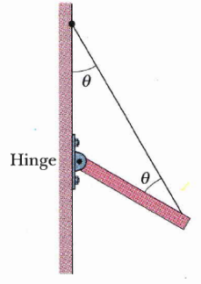
ANSWER: (a) 0.64 m; (b) increased
Fig. 3
5. In Fig. 3, one end of a uniform beam of weight 222 N is hinged to a wall; the other end is supported by a wire that makes angles θ = 30.0º with both wall and beam. Find
(a) the tension in the wire and the
(b) horizontal and
(c) vertical components of the force of the hinge on the beam.
ANSWER: (a) 192 N; (b) 96.1 N; (c) 55.5 N
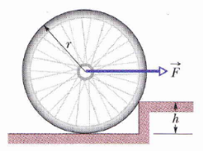
6. door has a height of.2.1, m along a y axis that extends vertically upward and a width of 0.91 m along an x axis that extends outward from the hinged edge of the door. A hinge 0.30 m from the top and a hinge 0.30 m from the bottom each support half the door's mass, which is 27 kg. In unit-vector notation, what are the forces on the door at
Fig. 4
(a) the top hinge and
(b) the bottom hinge?
ANSWER: (a) 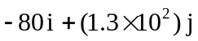; (b) 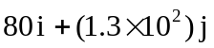
7. In Fig. 4, what magnitude of (constant) force F applied horizontally at the axle of the wheel is necessary to raise the wheel over an obstacle of height h = 3.00 cm? The wheel’s radius is r = 6.00 cm, and its mass is m = 0.800 kg.
ANSWER: 13.6 N
8. A75 kg window cleaner uses a 1-0 kg ladder that is 5.0 m long. He places one end on the ground 2.5 m from a wall, rests the upper end against a cracked window, and climbs the ladder. He is 3.0 m up along the ladder when the window breaks. Neglect friction between the ladder and window and assume that the base of the ladder does not slip. When the window is on the verge of breaking, what are
(u) the magnitude of the force on the window from the ladder,
(b) the magnitude of the force on the ladder from the ground, and
(c) the angle (relative to the horizontal) of that force on the ladder?
ANSWER: (a) 2.8 × 10² N; (b) 8.8 × 10² N; (c) 71º

